**PRACTICAL 2 : Creating account, repository on Github and cloning**

**repository in Github**

**a) Creating account :-**

**Step 1:- Search Github on Google and click on the official link of Github**

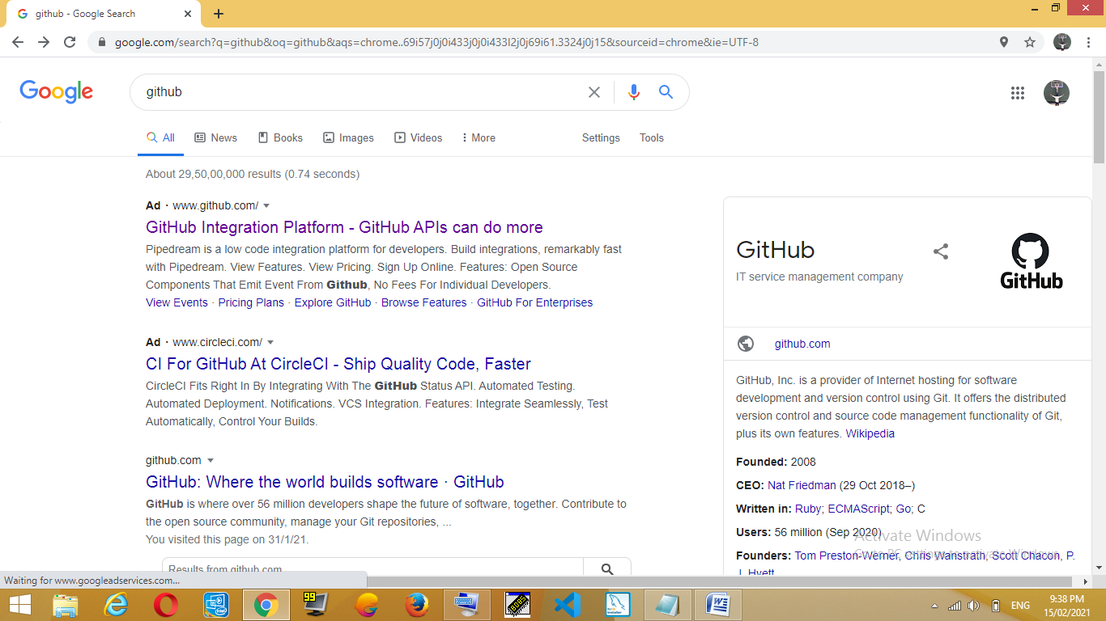

**Step 2:- Click on the sign up button to create an account on Github.**

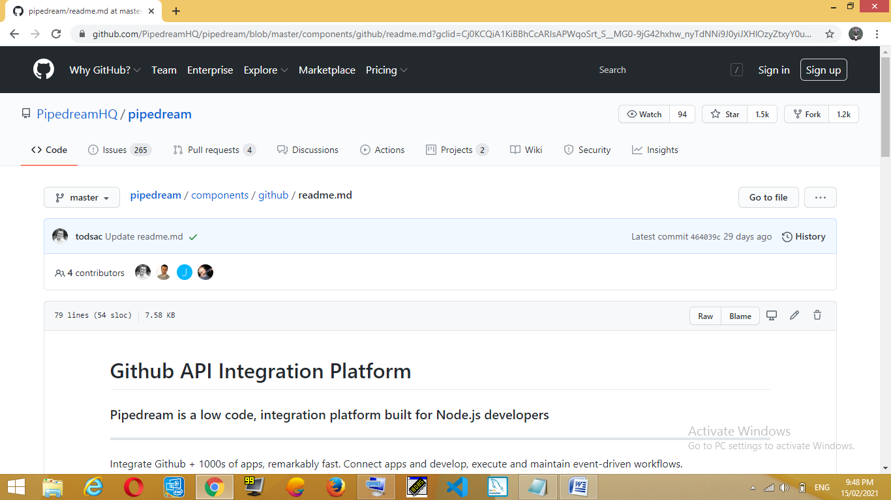

**Step 3:- Click on the signup button and Create your Github Account by filling necessary Information which is star marked.**

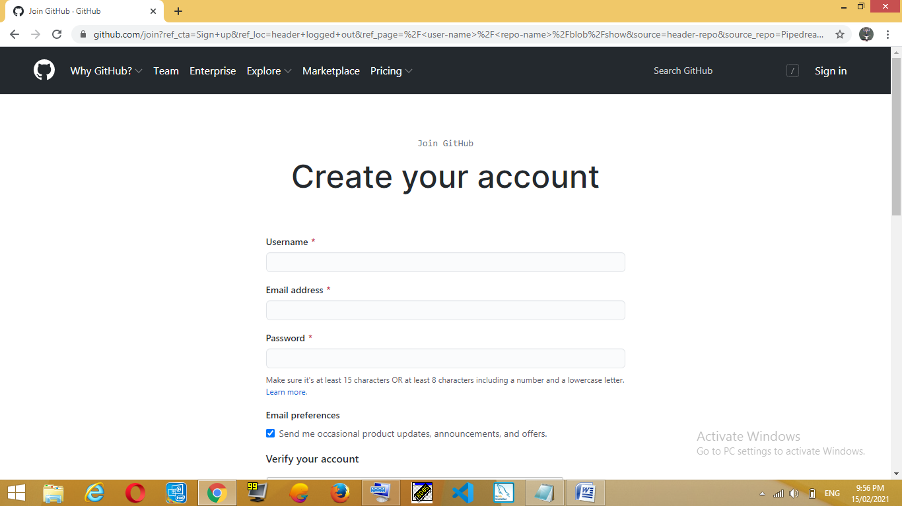

**INSERT YOUR EMAIL ID**

**INSERT PASSWORD**

INSERT USERNAME

**Step 4:- After fill all the information verify your account and click on the Create Account button. Now your account is created.**

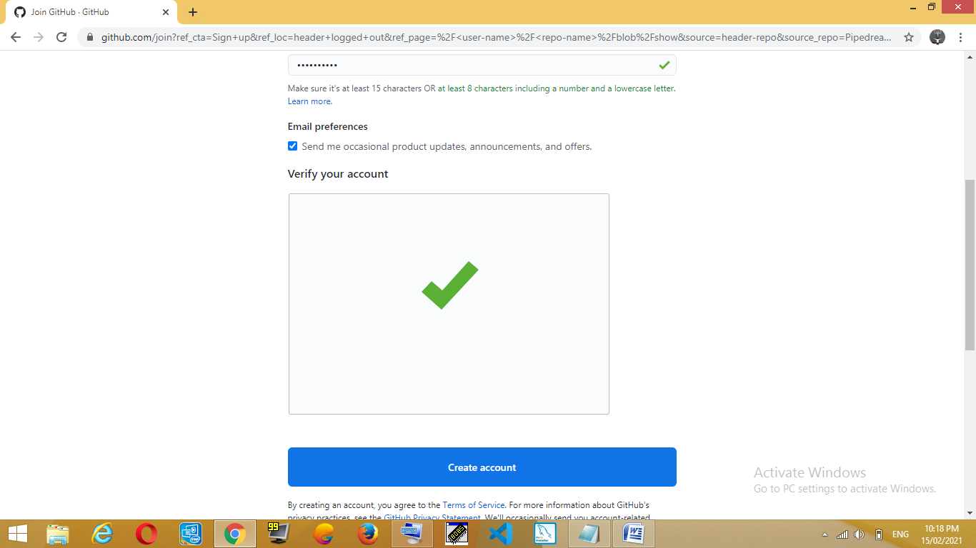

CLICK ON CREATE ACCOUNT

Verify account by solving puzzle

**b) Creating repository :**

**Step 1: To create repository click on the ‘+’ button.**

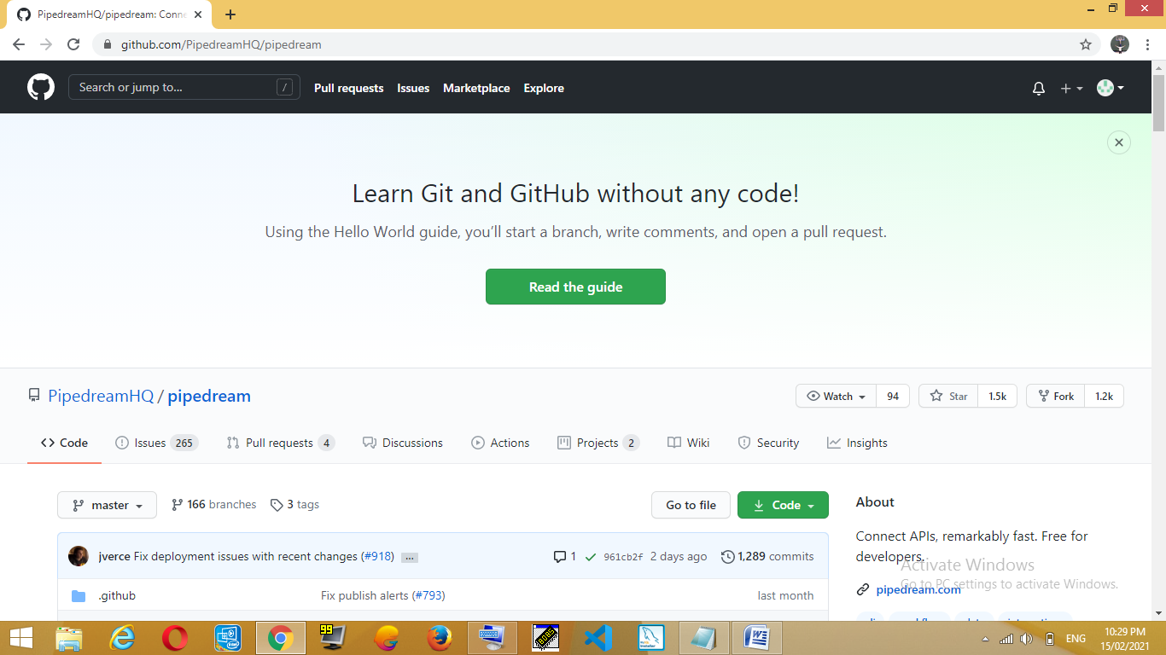

**Step 2: Click on New repository to make your repository.**

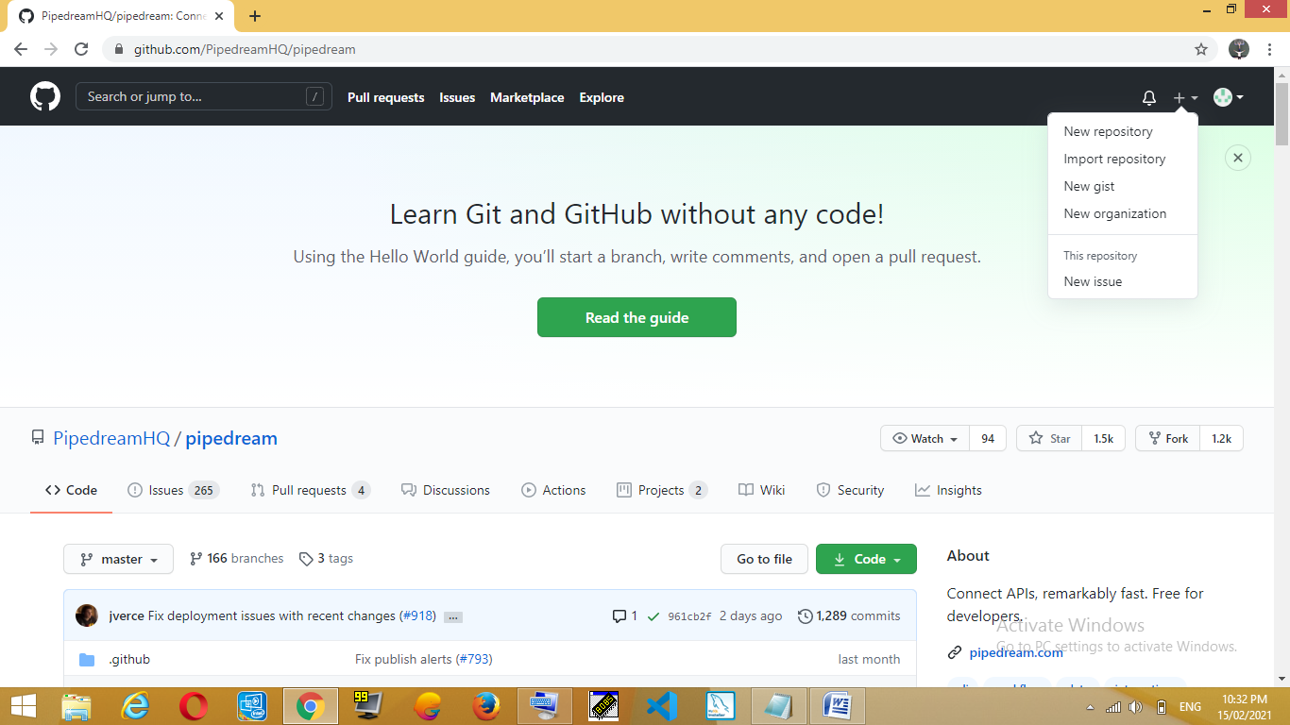

**Step 3: After clicking on the new repository you reach on this page here you have to give your Repository name, click on the private or public button.**

**Description: It is optional, so if you want to describe something about your repository then fill the description filled with necessary information.**

**1. Private : If you want no one can access your repository then click on private button.**

**2. Public : If you want other people can access your repository then click on public button.**

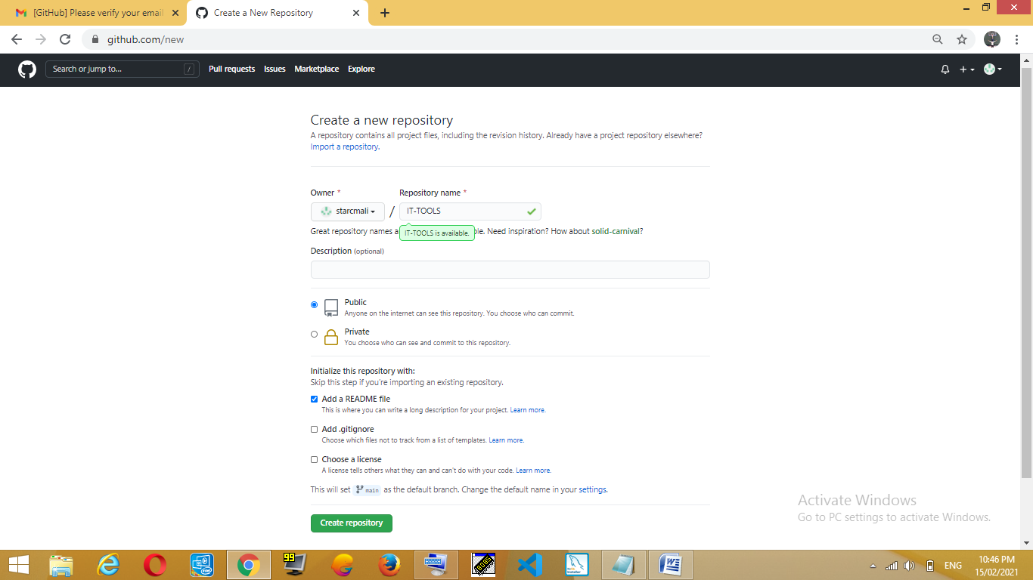

CLICK ON CREATE REPOSITORY BUTTON

SELECT ONE OF THEM

DESCIPTION ABOUT YOUR REPOSITORY

NAME OF YOUR

REPOSITORY

**Step 4: In the Last click on the create repository button.**

**c) Cloning repository :**

**After clicking on the create repository button you will reach on the below page.**

**Step 1: Click on the Add file button.**

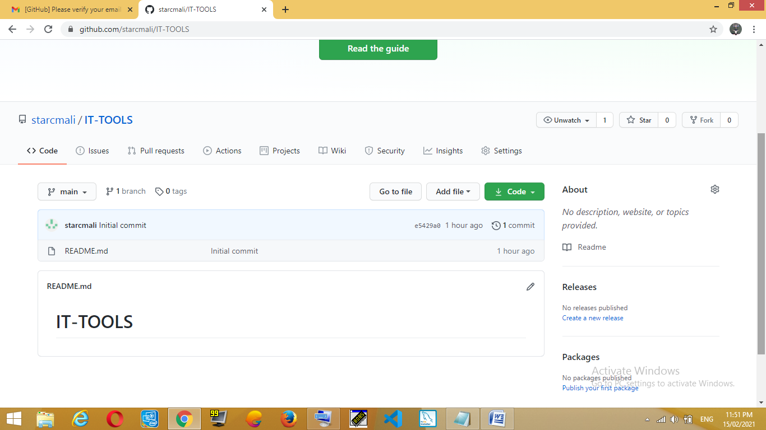

CLICK HERE TO ADD YOUR FILE

**Step 2: Click on upload files here you can add many files in the repository.**

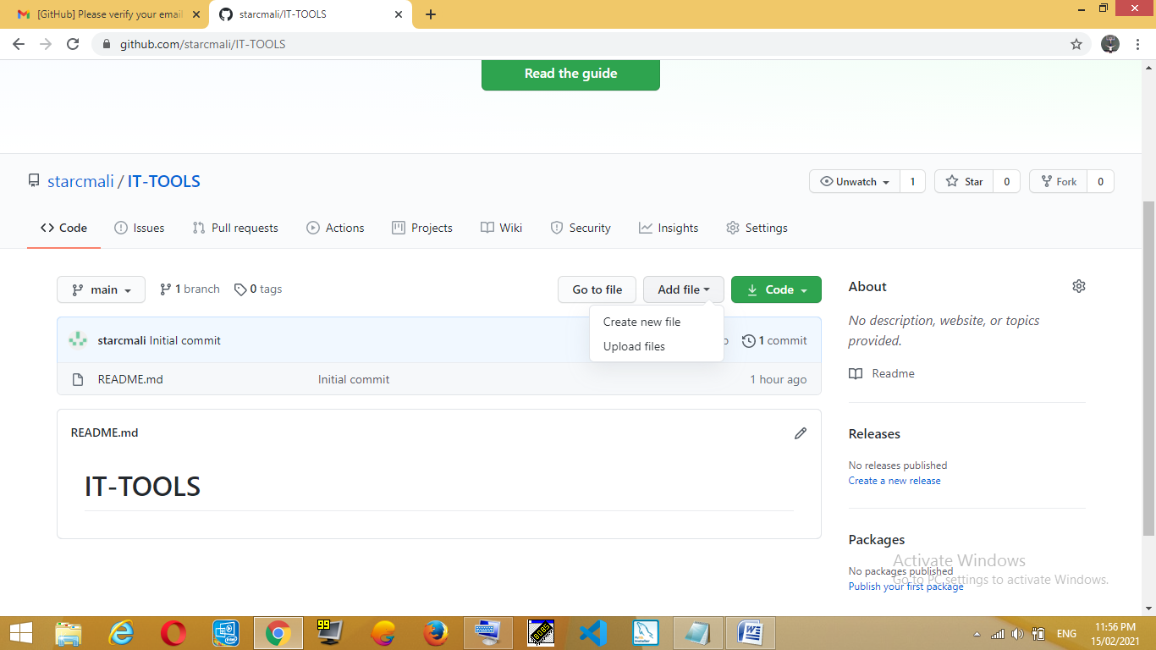

**Step 3: Click on choose your file to select your file.**

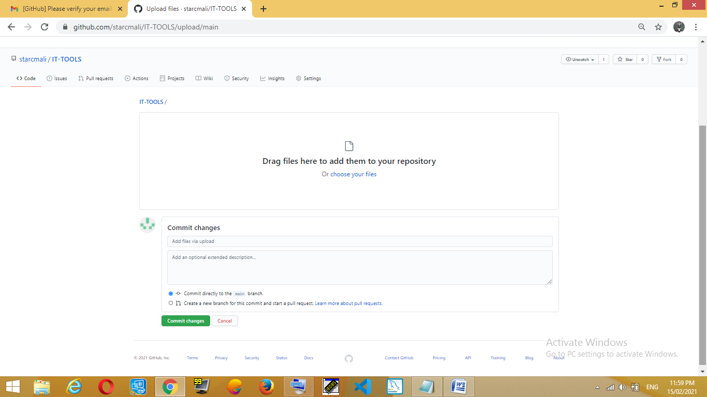

**Step 4: Select the file which you want and click on open button and atlast click on the commit changes button to save the changes.**

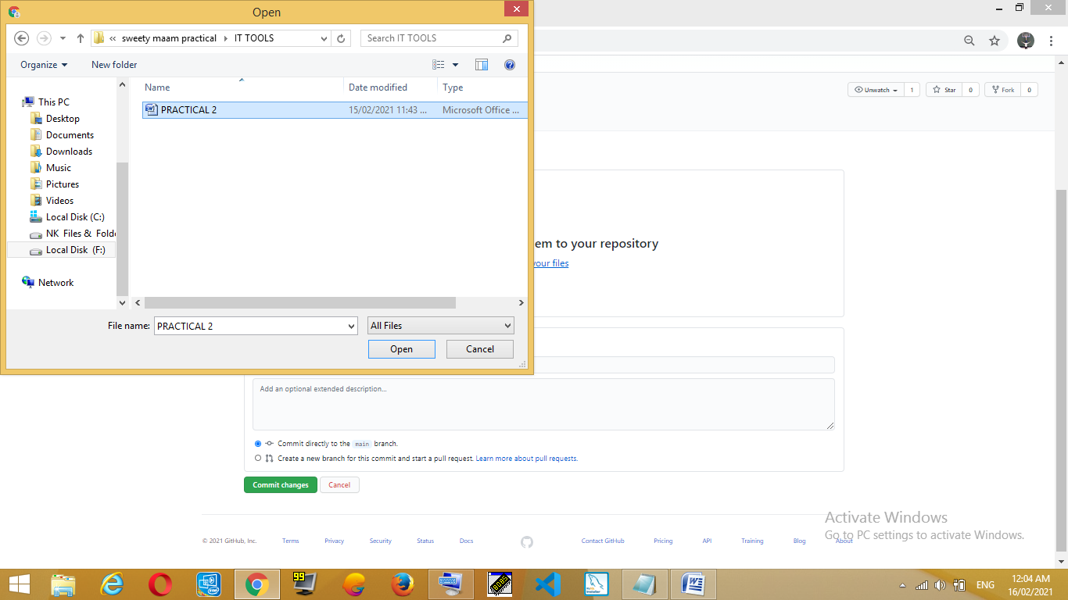

**Step 5: Click on the code button to get your repository link and copy the link to share your repository.**

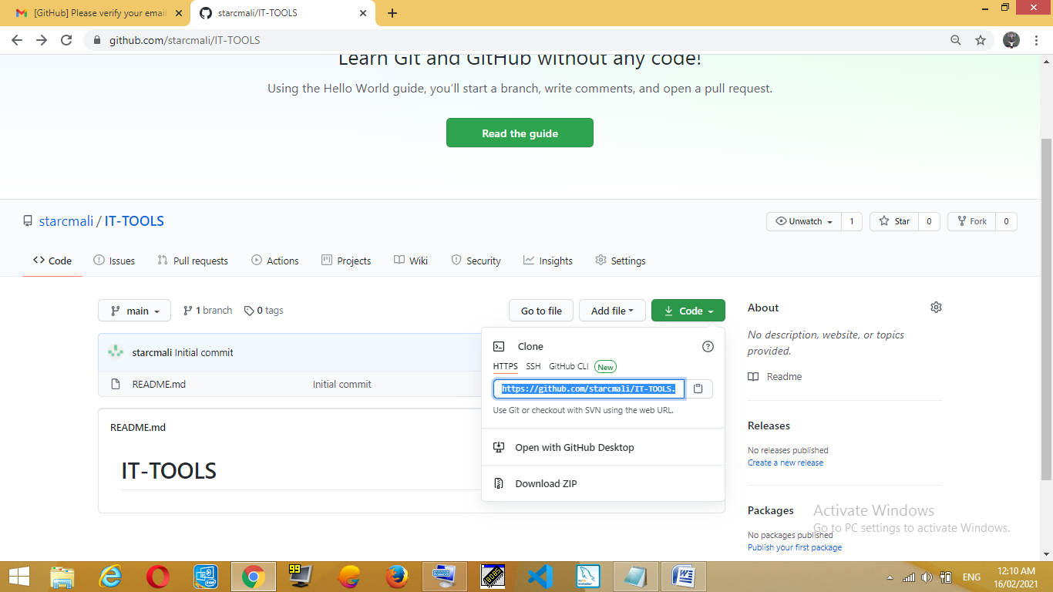

LINK OF THE REPOSITORY

CLICK ON THE CODE BUTTON